**COUHEA GEOGRAPHY MARKING GUIDE 2024.**

**SECTION A: MAP AND PHOTOGRAPHIC SKILLS.**

**ITEM 1**

1. **Identification of the problem:** Lack of knowledge about the geography of the Lukaya. **(01 score)**

C2 – Geography of the area (should look at physical and human geography.)

* Physical geography should look at relief, drainage, vegetation, climate, soils i.e.

1. In terms of drainage, Lukaya has seasonal and papyrus (permanent) swamps for example west of L. Victoria. Lwanswaswa swamp, Kasambya e.t.c.
2. There is a lake (Victoria) in the south east.
3. Numerous rivers like Kafu in the North.
4. In terms of relief, the area is generally flat especially in the east and central parts e.g. Ntizi, Kasambya, Kafu.
5. There are gentle slopes in the west at Lugasa, Buyikuzi, Lusango.
6. Broad valleys exist e.g Katabazungu in the southwest.
7. There is a basin in the southeast occupied by L. Victoria.
8. In terms of vegetation, there are forests north of Kafu, scrubs exist in central and eastern parts, woodland in southeast and central parts.
9. Soils: clay soils in swampy areas, loam soils due to L. Victoria.
10. Heavy rainfall evidenced by L. Victoria.
11. In terms of settlement, dense settlement in the northeast and southwest, sparse settlement in poorly drained areas around L. Victoria.

Scores.

* More than 6 responses with evidence (04 scores)
* 4 – 5 responses with evidence (03 scores)
* 3 – 4 responses with evidence (02 scores)
* 1 response (01 score)
* 00 (0 scores)

**N.B: Any responses with no evidence gets 01 score.**

1. **Problem statement:** Lack of knowledge about problems facing Lukaya and solutions **(01 score)**

Activities in the area – grazing, swamp draining, settlement, fishing.

Problems facing Lukaya

* Flooding due to presence of L. Victoria and surrounding swamps plus encroachment/ settlement in valleys.
* Pests and diseases because swamps habour mosquitoes that transmit malaria.
* Difficulty in construction of transport routes due to presence of many swamps in central, southeast and northeast e.g. Katonga swamp.
* Wild animals from forests north of Kafu which attack people and crops.
* Dense population in northeast and southwest which lead to spread of diseases.
* Some areas are remote with no clear transport routes e.g. central and western parts.
* Inadequate social services like hospitals, schools.

Scores.

* 4+ responses (02 scores)
* 1 – 3 responses (01 score)
* 0 response (0 scores)

Solutions

* Stay away from swamps to avoid flooding
* Afforestation
* Re-afforestation
* Controlled grazing
* Construction of drainage channels
* Construction of roads in western and central regions.

Scores.

* 4 responses and above. (02 scores)
* 1 – 3 responses (01 score)
* 0 responses (0 scores)

Part (a): 05 scores

Part (b): 05 scores

Total: 10 scores.

N.B: Part (b) 01 score should be either on a problem statement or human activities**. EITHER OF THE TWO AND NOT BOTH.**

**ITEM 2**

1. **Problem statement:** Lack of knowledge about impact of fishing on the physical environment. (**01 score)**

**Introduction:** Fishing is the extraction of aquatic life from water bodies. This activity is done using various methods such as gill netting, trawling , purse seining etc **( score 1)**

**Impact of fishing on the physical environment.**

* Over fishing due to use of poor nets has resulted into depletion of fish species.
* Pollution of water due to oil spills from engine boats.
* Fish smoking lead to destruction of vegetation
* Fish smoking leading to pollution of air (CO2)
* Fish wastes pollute water.

**(03 scores)**

Above 4 points -3

Between 2- 3 -2

1 point - 1

**Solutions**

* Use recommended nets.
* Use other preservation methods like freezing, icing.
* Purification to avoid water pollution
* Sensitisation about appropriate fishing nets.
* Introduction of licenses by government to curb illegal fishing.
* Strict laws.

**(03 scores)**

Above 4 points -3

Between 2- 3 -2

1 point - 1

**Opinion :** Depends on the learner e.g if the above solutions are effected the rate of environmental deterioration due to fishing activities will be reduced. **(02 scores)**

ITEM 3.

Problem identification: Lack of knowledge about the origin/ formation of a rift valley.

Description of the formation of a rift valley.

A rift valley is an elongated trough with in two in facing fault scarps. It was formed by a process called faulting. Faulting was brought about by geochemical reactions and radioactivity due to excessive heat and pressure from within the earth’s crust. This led to the formation of tensional forces and compressional forces.

2 scores; explanation(2), mere mentioning (1) and wrong information (0)

Tensional force theory.

Tensional forces pulled land blocks to either sides. Continuous pulling of the blocks created normal fault lines. This forced the middle block to sink under its own weight block to sink under its own weight creating a depression known as a rift valley. (03 scores)

Diagrammatically.

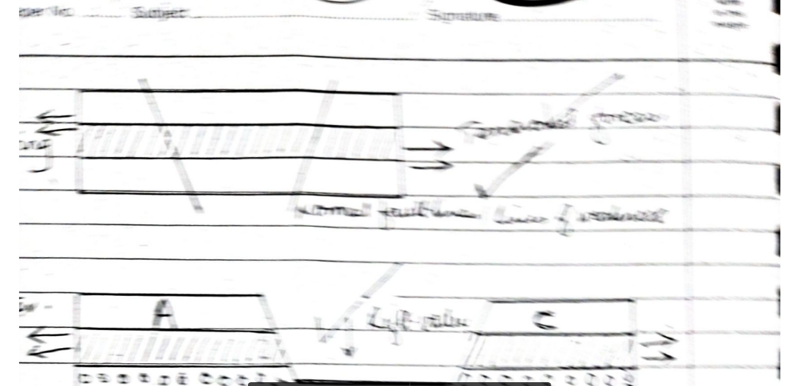

Compressional force theory.

Compressional forces pushed the land blocks/ rocks together. When compressional forces continued pushing the land blocks, reversed fault lines were created. This forced the side blocks to override the middle block creating a depression known as a rift valley. Over time, the sharp edges were reduced by erosion to create smooth escarpments. (03 scores)

Diagrammatically.

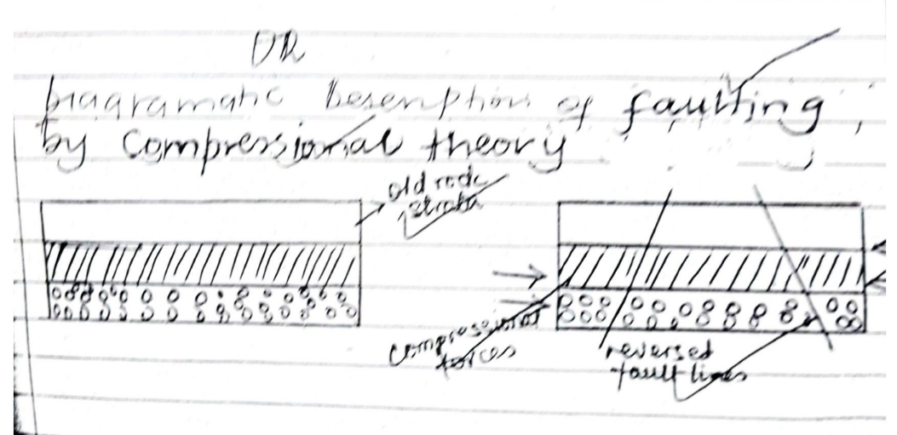

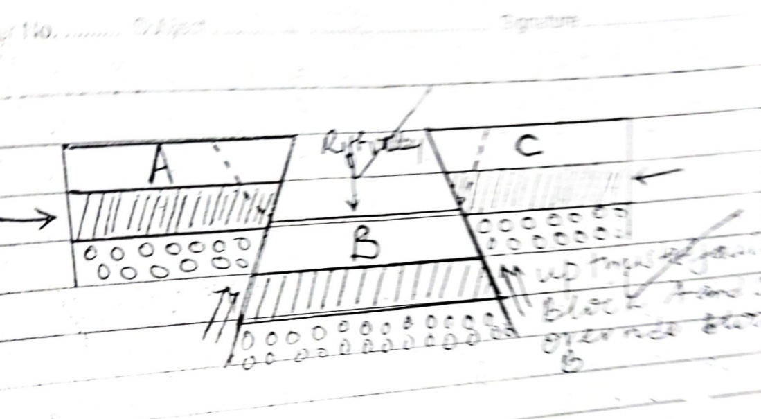

Scores.

* Correct explanation and diagram (6 scores)
* Explanation without diagram (04 scores)
* Mere stating of the theories (02 scores)
* Mere stating of one theory (01 score)
* Wrong/ no information (0 scores)
* Personal opinion (01 score)

N.B: The candidate gets only 03 scores for one theory.

ITEM 4.

Problem identification: Lack of knowledge about the problems/ challenges faced by the people living near rivers.

Challenges faced by the people living near rivers.

* Flooding leading to loss of property.
* Habitat for diseases causing organisms like mosquitoes, snails, e.t.c.
* Barriers to transport and communication hence hindering trade and other activities.
* Rivers are associated with aquatic animals which attack people, domestic animals and crops like crocodiles, hippos, e.t.c.
* The floating vegetation like sudds that interfere with vegetation.

Scores.

* 5+ (04 scores)
* 3 – 4 (03 scores)
* 1 – 2 (02 scores)
* Merely states (01 score)
* No/ wrong information (0 scores)

Solutions.

* Carry out continuous dredging to control floods.
* Construct embankments to control floods.
* Spraying using chemicals to control diseases.
* Sensitisation of local people.

Scores.

* 6+ (04 scores)
* 4 – 5 (03 scores)
* 3 and below (02 scores)
* Merely lists/ just a statement of opinion (01 score)
* Wrong/ no response (00 scores)

ITEM 5

In the different cities of the East Africa, population size has doubled in the recent

years due to increased job opportunities, better social services and other. The city

planners are worried of the increase and have organized a meeting with the city

authorities to address the challenges before it is too late. You have been invited to

address the leaders.

STUDY MATERIAL.

The table below shows the population of the selected cities in East Africa between

1910-2010 and answers the tasks given below.

TOWN/

CITY

POPULATION IN THOUSANDS

(000)

1970 1990 2010

NAIROBI 28.7 37.7 47.6

KAMPALA 24.2 34.8 38.7

DODOMA 34.4 44.9 47.4

TASK.

a) Write a sensitization message that you will present in the meeting.

b) Use a suitable graph to represent the information in the table above.

SOLUTION (A)

C1 – Identification of the problem:

Lack of knowledge about the challenges of an increasing population in the cities of

East Africa. (1score)

C2- Suggesting the likely challenges of an increasing population in cities.

ie unemployment, slum development, pressure on land, stiff competition on

resources, high spread of diseases, traffic congestion, overcrowding, swamp

reclaiming, vegetation destruction, high standards of living, high crime rates,

straining of city authority budget, poor disposal of garbage/ poor sanitation and

waste management/sewage flow, land fragmentation, insufficient health resource

to meet growing population, poor public service and governance,

C3- Solutions to the challenges of an increasing population the selected cities

of East Africa.

- Carrying out comprehensive city planning to manage the growth sustainably

-Extending quality and better social service in rural areas.

-Establishment of industries in rural to create job.

-Encouraging education to limit early marriages among city dwellers.

-Adoption of family planning and birth control methods in cities.

-Restricting and regulating rural urban movements.

-Sensitizing urban dwellers of the dangers of an increasing population in cities.

-Encouraging urban-rural movements.

-Incorporating population figure into economic planning.

-Implementing population policies and related research.

-Restricting wetland/swamp encroachment and continuous evictions.

-Housing and slum upgrade through affordable housing schemes for better living.

-Expansion and maintenance of road networks/ use intelligence traffic management

systems.

-Modern waste management and collection facilities/ Recycling management

initiatives.

-Promote entrepreneurship, support of medium size business and skilling youth.

-Streamlining government services through technology

-Strengthening city policies to reduce crimes/ support youth at risk.

**C4- Opinion**, Must be related to the problem, reflecting population control as

challenge, pointing out concern of strengthening the strategies,

(1score)

**Item 6**

Problem identification: Lack of knowledge about the challenges facing the transport sector in Africa.

Scoring: correct statement (01 score)

Wrong/ no response (00 scores)

Challenges or problems facing the transport sector in Africa.

* Remoteness of some areas making them highly inaccessible.
* Rugged relief e.g. mountainous areas making construction expensive and difficult.
* Many roads are in poor conditions with potholes making them impassable and longer.
* Poor drainage system in some areas e.g. swampy areas making them difficult to cross.
* Waterfalls along some African rivers limiting the movement of water vessels.
* Meanders along some rivers making the journey longer.
* Existence of dense forests making road construction expensive.
* Limited skilled labour to construct transport routes.
* Political instability in some countries scares away workers and destroys the already existing infrastructure.
* Limited capital to purchase modern machinery used in construction of transport routes.
* Floating vegetation limits movement of vessels.
* Poor government policy towards infrastructural development e.g. poor funding.
* Occurrence of floods in some areas which washes away bridges, roads e.t.c.
* Low levels of technology hinder the development of modern transport facilities e.g. electrified railway, digital payments e.t.c.
* Corruption and embezzlement of funds meant for infrastructural development.
* Limited regional integration in many African countries makes it difficult to move between borders.
* Accidents leading to death and loss of merchandise.

Scores.

* Explains 5 and more problems (03 scores)
* Explains 3 – 4 problems (02 scores)
* Explains 1 – 2 problems (01 score)
* Wrong/ no response (00 scores)

Solutions.

* Regular maintenance of transport routes like roads and railway to prevent deterioration.
* Provision of capital through loans and grants to develop transport systems.
* Promote private-public partnerships to finance transport projects.
* Improve road safety to avoid accidents e.g. installation of cameras.
* Improve technology to come up with modern transport systems e.g. electric railway.
* Training of labour and capacity building to produce skilled drivers and engineers.
* Construction of canals to by-pass waterfalls and rapids.
* Enhance regional integration to help in implementation of policies and systems that facilitate the movement of goods and people along borders.

Scores.

* 5 and above (03 scores)
* 3 – 4 solutions (02 scores)
* 1 – 2 solutions (01 score)
* Wrong/ no response (00 scores)

b)